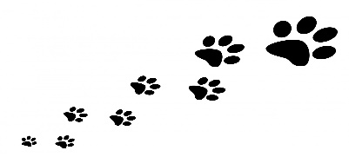
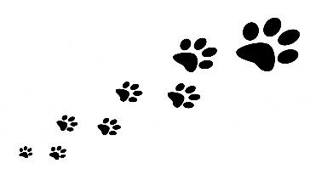
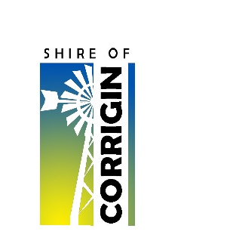
CORRIGIN DOG CEMETERY
APPLICATION FOR BURIAL & INSTRUCTION OF GRAVE
Owner Details
Surname
Given Name
Address
Mobile
Email
Dog Details
Name
Breed
Age
Date of Birth
Date of Death
Grave & Burial Details
Grave No
Burial Date
Monument shape | Hexagon Heart
Instructions for grave

Owner Signature: _____________________________ Date: ______________________
PLEASE NOTE:
- All graves are dug to a depth of 1.2m. All dog owners are required to bring a shovel and fill in the grave themselves.
- We encourage owners to personalise their dog’s monument. This may include items such as an old collar, favourite toy, or any decorative or ornamental objects meaningful to your dog. Adding these items is the owner’s responsibility.
- Grave Monuments: We allow 6–8 months after burial before any monument work takes place. You will be notified once the monument has been completed.
- The Shire of Corrigin is not responsible for the ongoing upkeep or maintenance of monuments

Burial fee
Grave Site Allocation | $50
Grave Digging (+ 50% surcharge on an RDO, weekend or public holiday) | $200
Grave Slab (Shire supply and install) | $150
Monument (Shire supply and install) | $100

OFFICE USE ONLY:
Fee Paid | Yes No $ | Receipt No:
Authorised By
Signature |  | Date
Examples of plaques that you can add on

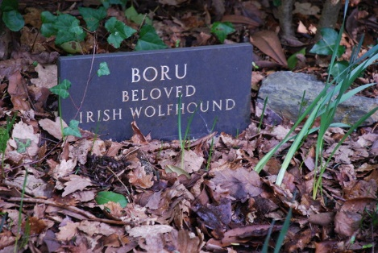
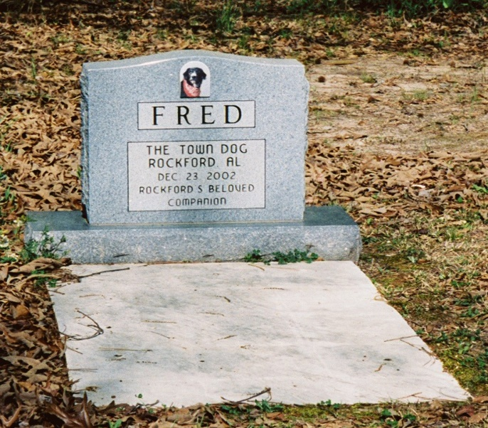

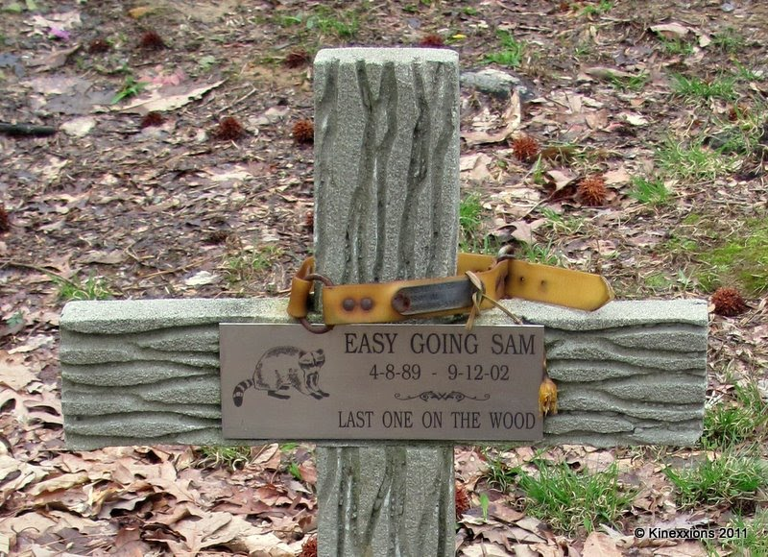
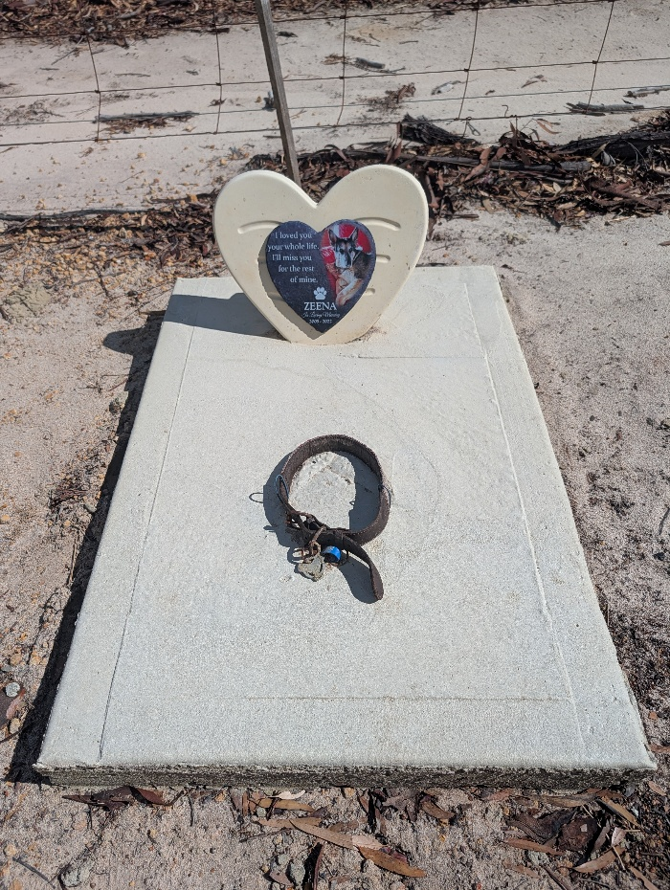

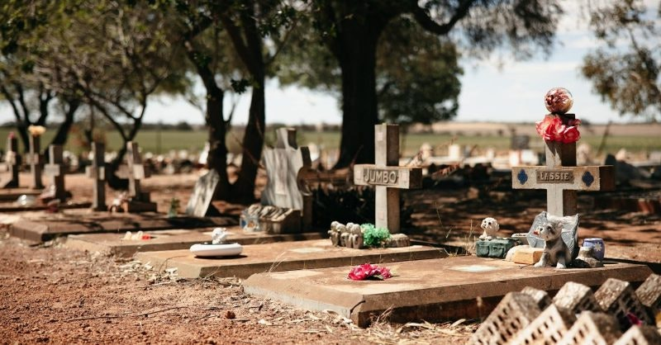

Dog Cemetery Monument Shape

Hexagon

Heart

Dog Cemetery Grave Design

Top view of grave

Shaped Monument
Concrete Slab
<- 700mm ->
<- 1000mm ->
Shaped Monument
Side view of grave
Concrete Slab

